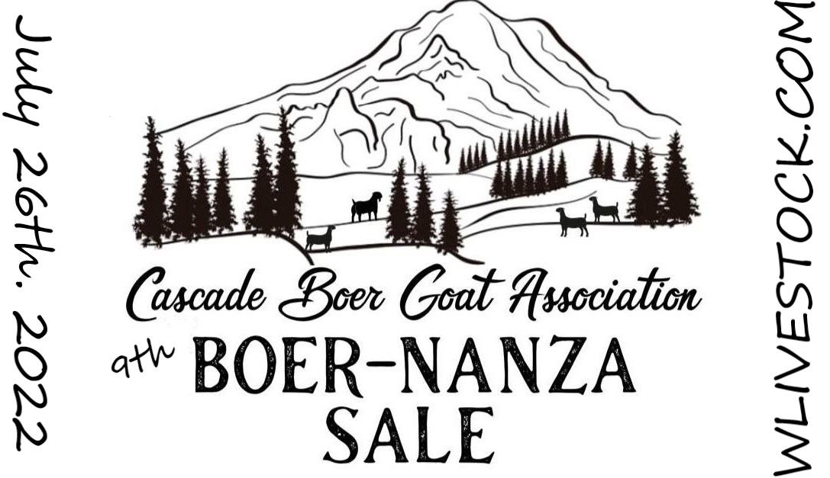
Consignor Information Packet

General Information:
- The date for the sale is Tuesday, July 26th, 2022.
- Bio-security testing is NOT required this year.
- Preview of catalog will be up on WLIVESTOCK by July 12th.
- The sale will be open for bids Tuesday, July 26th at 0800 EST until 2100 EST.
- Consignors need to upload pictures, video, pedigree, and descriptions by July 10th^{th}, 2022.
- The sale will be virtual and held ONLINE ONLY.
ALL SALE MONEY WILL GO THROUGH WILLOUGHBY SALES.

Consignment Information:
1) Only members in good standing with Cascade Boer Goat Association may consign Boer
goats to the sale.
2) Consignment fees are $15.00/per lot and are non-refundable, except in the event the
sale is canceled by the CBGA.
3) A minimum 10% (of total sale amount) processing fee will be charged by Willoughby sales to
sellers at time of payout. Commission amount is lowered to as total sale amount increases.
Please see the break down of WLIVESTOCK commission fees below.

Break down on commission to WLIVESTOCK:
$4000-$12000 total sales =10% with 400 minimum fee
$12k -$15k =8%
$15k-$25k = 6%
EXAMPLE: If we have a total sale of $12,000 and 75 lots, the fee to Willoughby would be $1200, divided by 75 lots, would be a fee of $16 per lot.
- No other fees to buyers or sellers.
- No charge on buyback or no sales just commission off total sales.
4.) Initial consignment dates are May 7th to May 14th, 2022. During this period each member
farm may consign up to 10 goats to the sale. When the total number of consigned goats
reaches 75, the sale will be declared full.
5) One semen or embryo lot will be allowed per consignor as consignments or substitutions
but will be considered the same as a buck and subject to the same rules as bucks in rule
13. A donation semen consignment benefitting the CBGA youth shows will be allowed.
The donation semen consignment will sell as lot #1 and will accommodate a reasonable
number of donations at the sole discretion of the CBGA board.
6) Consignments are not considered ‘reserved’ until the consignment form is completed,
and fees are paid in full. Paypal is the preferred method of payment and using “friends
and family”. Personal checks will still be accepted as payment but will not be considered paid
until the day they arrive in the sale chairman’s mailbox.
7) In the event the sale is filled, a waiting list will be formed in the order the excess
consignments are received. Prospective consignors not wishing to be or remain on the
waiting list will be refunded in full at the time of their request. Prospective consignors on
the waiting list not getting into the sale will be refunded in full.
8) Consignors wishing to relinquish all or part of their paid lots before June 26th, 2022 must contact the sale chairman for reissue to the waiting list, if there is a waiting list.
- Consignors cannot sell their lots to prospective consignors of their choosing. If there are no prospective consignors on the waiting list, the original consignor will not receive a refund of their consignment fees
- If a consignor relinquishes their lot(s) on or before June 26th, 2022, which are filled through the waiting list, the original consignor will receive a full refund of their consignment fees.
- If consignor relinquishes their lots after June 26th, 2022, consignor will not receive refund for lots cancelled.
9) Lots containing more than one animal are allowed if the animal involves kids that are still
nursing on their dam.
10) Photos, pedigree information and descriptions for consigned goats must be uploaded to
WLIVESTOCK.com per the schedule below.
11) The catalog will be maintained on the WLIVESTOCK.com site.
12) Member farms consigning a minimum of 4 does, may also consign 1 buck. Member
farms consigning a minimum of 8 does, may also consign up to 2 bucks. No farm may
consign more than 2 bucks to the sale.
13) Consigned bucks must be registered. Unregistered Boer does shall be designated as
such in the sale catalog and announced by the auctioneer. Dairy and other breed goats, less
than 50% Boer, shall be excluded from this sale, unless they are implanted with boer goat
embryos and confirmed to be pregnant.
14) Sellers may place reserves with the auctioneer. The floor price, unless instructed by the
seller, otherwise, will be $300.00.
15) All consigned pictured goats should be presented well-groomed and in good health.
Goats who exhibit signs of illness or a communicable condition will be pulled from the sale.
16) Goats may only be listed as CAE/CL/Johnes/Q-FEVER tested or listed as clean with current testing and results within 30 days of sale day. Results must be in sale chairs email by July 10th, 2022.
- Consigned animals under 6 months old, EXEMPT from biosecurity testing.

17) All consignors must be willing to hold consigned goats for two weeks after the sale date
to allow for buyers to arrange transportation. Consigned goats must be transported with
the following:
▪ Original signed registration papers.
▪ If a doe is being sold ‘bred’ or ‘exposed’ that must be noted properly on the back
of the registration form. With breeding slip if not noted on the registration papers.
▪ A copy of testing result ( IF BEING LISTED AS CLEAN TESTED)

Sale Schedule:
May 7th – May 14^{th,} 2022 | Initial Consignment Period.
May 15th – May 22nd , 2022 | Consignors may purchase up to 2 additional lots of sale is not yet declared “full”
July 10th, 2022 | Photos, pedigree information and descriptions of consigned goats  to be uploaded.
July 12^{th,} 2022 | Final Online Catalog updates
July 10th, 2022 | Test results must be in sale chairs possession
July 26th, 2022 | Sale Will open 0800 EST until 2100 EST.

If you have any questions, please contact:
Briana Rask
360-270-7373
cbgasale@gmail.com

